List of contents of the presentation

1 The community of alleged electromagnetic
harassment targeted individuals

2 The four capabilities covered by this presentation

2.1 Frey effect voice transmission
2.2 Target tracking
2.3 Biotelemetry
2.4 Thought inference from biological data

- Discussion of applications enabled by the four capabilities (and also alleged)

4 Societal and ethical implications of the applications enabled

4.1 The ethos of abusers
4.2 Media coverage
4.3 Medicine
4.4 Politics
  - Jurisprudence and law-enforcement
  - A Christian perspective on the enabled applications



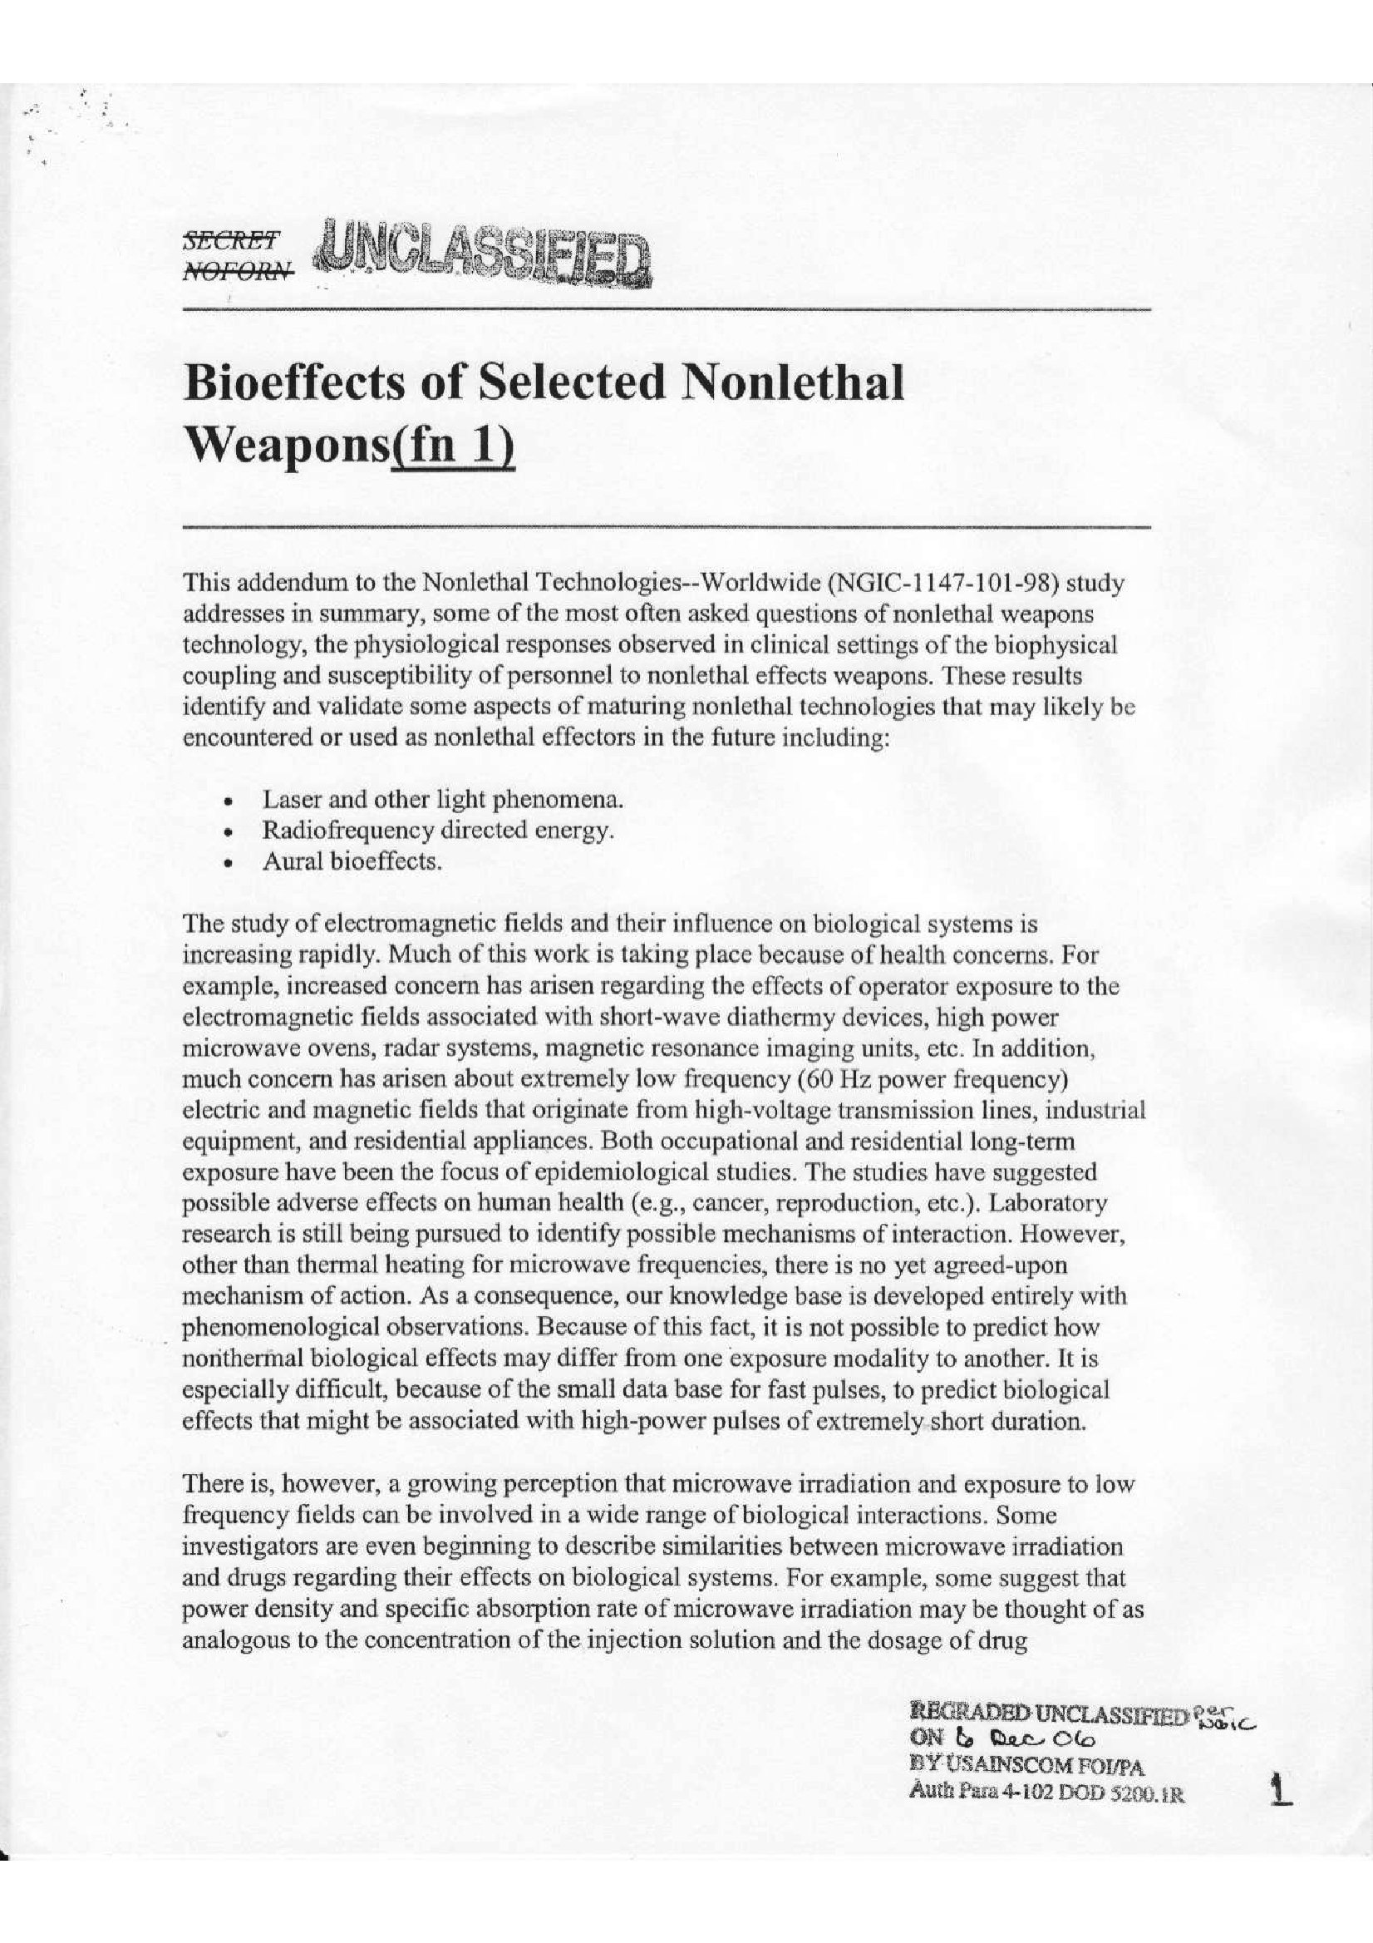
Christians Against Mental Slavery
SCIENCE PAGE
Press Reports
New Scientist report about the latest V2K weapon - "MEDUSA" - CAMS' response
Military Sources
Bioeffects of Selected Non-Lethal Weapons
Neuroelectric Activity and Analysis in Support of Direct Brainwave to Computer Interface Development
Radiofrequency Radiation Dosimetry Handbook
Literature Review Papers
by American biologist and Christians Against Mental Slavery member John McMurtrey M.S.
Project Bizarre Weapons Implications: Are Psychiatric Diagnosis, and Microwave Exposure Standards Presumptive?
A Simulated Hallucination Mechanism Compared to Hallucination Brain Response Studies
Inner Voice, Target Tracking, and Behavioral Influence Technologies
Thought Reading Capacity
Physiologic Word Recognition
Remote EEG Discussion
Recording Microwave Hearing Effects
Microwave Bioeffect Congruence With Schizophrenia
Remote Behavioral Influence Technology Evidence
Other Resources
Feasibility Study for Design of a Biocybernetic Communication System - Pinneo
On the Need for New Criteria of Diagnosis of Psychosis in the Light of Mind Invasive Technology – Carole Smith
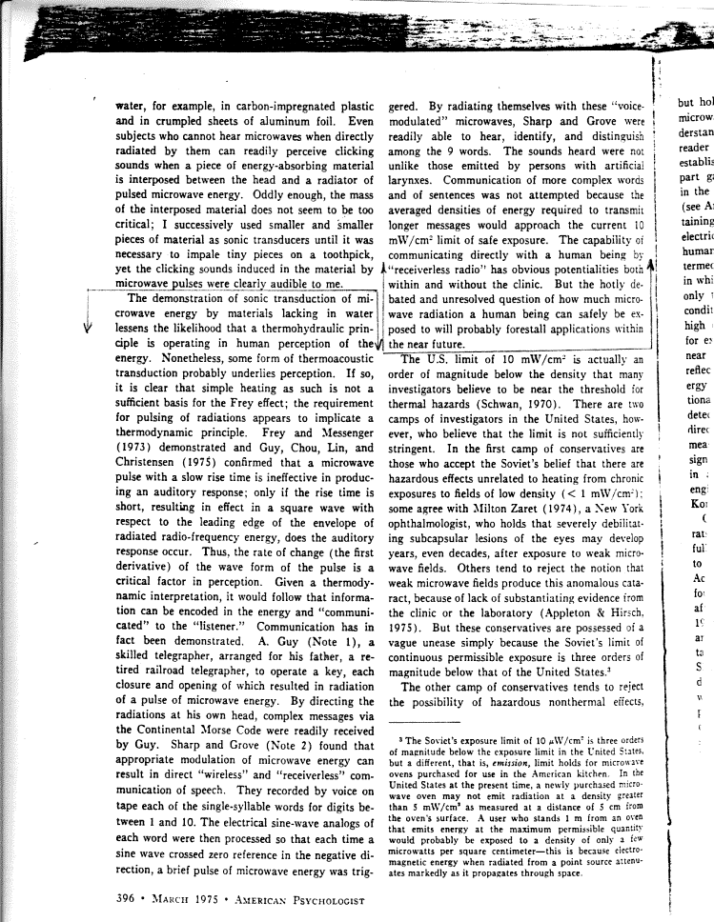


Army Yanks ‘Voice-To-Skull Devices’ Site
- By Sharon Weinberger
- May 9, 2008 |
- 8:26 am |
- Categories: Weapons and Ammo
The Army’s very strange webpage on "Voice-to-Skull" weapons has been removed. It was strange it was there, and it’s even stranger it’s gone. If you Google it, you’ll see the entry for "Voice-to-Skull device," but, if you click on the website, the link is dead.
The entry, still available on the Federation of American Scientists‘ website reads:
Nonlethal weapon which includes (1) a neuro-electromagnetic device which uses microwave transmission of sound into the skull of persons or animals by way of pulse-modulated microwave radiation; and (2) a silent sound device which can transmit sound into the skull of person or animals. NOTE: The sound modulation may be voice or audio subliminal messages. One application of V2K is use as an electronic scarecrow to frighten birds in the vicinity of airports.
The U.K.-based group Christians Against Mental Slavery first noted the change (they also have a permanent screenshot of the page). A representative of the group tells me they contacted the Webmaster, who would only tell them the entry was "permanently removed.


Mind Games
New on the Internet: a community of people who believe the government is beaming voices into their minds. They may be crazy, but the Pentagon has pursued a weapon that can do just that.
By Sharon Weinberger
Sunday, January 14, 2007; W22
IF HARLAN GIRARD IS CRAZY, HE DOESN'T ACT THE PART. He is standing just where he said he would be, below the Philadelphia train station's World War II memorial -- a soaring statue of a winged angel embracing a fallen combatant, as if lifting him to heaven. Girard is wearing pressed khaki pants, expensive-looking leather loafers and a crisp blue button-down. He looks like a local businessman dressed for a casual Friday -- a local businessman with a wickedly dark sense of humor, which had become apparent when he said to look for him beneath "the angel sodomizing a dead soldier." At 70, he appears robust and healthy -- not the slightest bit disheveled or unusual-looking. He is also carrying a bag.
Girard's description of himself is matter-of-fact, until he explains what's in the bag: documents he believes prove that the government is attempting to control his mind. He carries that black, weathered bag everywhere he goes. "Every time I go out, I'm prepared to come home and find everything is stolen," he says.
The bag aside, Girard appears intelligent and coherent. At a table in front of Dunkin' Donuts inside the train station, Girard opens the bag and pulls out a thick stack of documents, carefully labeled and sorted with yellow sticky notes bearing neat block print. The documents are an authentic-looking mix of news stories, articles culled from military journals and even some declassified national security documents that do seem to show that the U.S. government has attempted to develop weapons that send voices into people's heads.
"It's undeniable that the technology exists," Girard says, "but if you go to the police and say, 'I'm hearing voices,' they're going to lock you up for psychiatric evaluation."
The thing that's missing from his bag -- the lack of which makes it hard to prove he isn't crazy -- is even a single document that would buttress the implausible notion that the government is currently targeting a large group of American citizens with mind-control technology. The only direct evidence for that, Girard admits, lies with alleged victims such as himself.
And of those, there are many.
IT'S 9:01 P.M. WHEN THE FIRST PERSON SPEAKS during the Saturday conference call.
Unsure whether anyone else is on the line yet, the female caller throws out the first question: "You got gang stalking or V2K?" she asks no one in particular.
There's a short, uncomfortable pause.
“Communicating Via the Microwave Auditory Effect” is the title of a small business contract for the Department of Defense. Communication initial results are: “The feasibility of the concept has been established” using both low and high power systems. [99] A Freedom of Information Act (FOIA) request as to the project’s final outcome met with denial on the part of the Air Force, on the grounds that disclosure “could reasonably be expected to cause damage to national security.” [100] Though the Air Force denied this FOIA disclosure, such a contract’s purpose is elaborated by the Air Force’s “New World Vistas” report: “It would also appear possible to create high fidelity speech in the human body, raising the possibility of covert suggestion and psychological direction . . . . If a pulse stream is used, it should be possible to create an internal acoustic field in the 5-15 kilohertz range, which is audible. Thus it may be possible to ‘talk’ to selected adversaries in a fashion that would be most disturbing to them.” [101] [102] …
Robert O. Becker, whose eminence was enough to have been twice nominated for the Nobel Prize in biological electromagnetic fields research, is explicit regarding clandestine use of radio frequency voice transmission: “Such a device has obvious applications in covert operations designed to drive a target crazy with “voices” or deliver undetectable instructions to a programmed assassin.” [107]

Microwave ray gun controls crowds with noise
- 17:06 03 July 2008 by David Hambling
- For similar stories, visit the Weapons Technology Topic Guide
A US company claims it is ready to build a microwave ray gun able to beam sounds directly into people's heads.
The device - dubbed MEDUSA (Mob Excess Deterrent Using Silent Audio) - exploits the microwave audio effect, in which short microwave pulses rapidly heat tissue, causing a shockwave inside the skull that can be detected by the ears. A series of pulses can be transmitted to produce recognisable sounds.
The device is aimed for military or crowd-control applications, but may have other uses.
Lev Sadovnik of the Sierra Nevada Corporation in the US is working on the system, having started work on a US navy research contract. The navy's report states that the effect was shown to be effective.

Scarecrow beam?
MEDUSA involves a microwave auditory effect "loud" enough to cause discomfort or even incapacitation. Sadovnik says that normal audio safety limits do not apply since the sound does not enter through the eardrums.
"The repel effect is a combination of loudness and the irritation factor," he says. "You can't block it out."
Sadovnik says the device will work thanks to a new reconfigurable antenna developed by colleague Vladimir Manasson. It steers the beam electronically, making it possible to flip from a broad to a narrow beam, or aim at multiple targets simultaneously.
Sadovnik says the technology could have non-military applications. Birds seem to be highly sensitive to microwave audio, he says, so it might be used to scare away unwanted flocks.
Sadovnik has also experimented with transmitting microwave audio to people with outer ear problems that impair their normal hearing.

Brain damage risk
James Lin of the Electrical and Computer Engineering Department at the University of Illinois in Chicago says that MEDUSA is feasible in principle.
He has carried out his own work on the technique, and was even approached by the music industry about using microwave audio to enhance sound systems, he told New Scientist.
"But is it going to be possible at the power levels necessary?" he asks. Previous microwave audio tests involved very "quiet" sounds that were hard to hear, a high-power system would mean much more powerful - and potentially hazardous - shockwaves.
"I would worry about what other health effects it is having," says Lin. "You might see neural damage."
Sierra Nevada says that a demonstration version could be built in a year, with a transportable system following within 18 months. They are currently seeking funding for the work from the US Department of Defence.
Target illumination tracking systems have nanosecond to microsecond response times. Such responses do not require a wide scan area to lock illumination upon a person at achievable speeds. At 90 miles per hour an auto travels less than 1/100 of an inch in a microsecond.
Rowan Patent # 4893815 “Interactive transector device commercial and military grade” describes the acquisition, locking onto, and tracking of human targets. [136] Stated therein: “Potentially dangerous individuals can be efficiently subdued, apprehended and appropriately detained.” The capability of “isolating suspected terrorists from their hostages . . . or individuals within a group without affecting other members of the group” is stated.

… the disappearance of physiological remote sensing literature since the 1970’s for animals and humans, while all other categories of remote sensing research greatly expanded.
United States Patent | 3,951,134
Malech | April 20, 1976

Apparatus and method for remotely monitoring and altering brain waves

Abstract
Apparatus for and method of sensing brain waves at a position remote from a subject whereby electromagnetic signals of different frequencies are simultaneously transmitted to the brain of the subject in which the signals interfere with one another to yield a waveform which is modulated by the subject's brain waves. The interference waveform which is representative of the brain wave activity is re-transmitted by the brain to a receiver where it is demodulated and amplified. The demodulated waveform is then displayed for visual viewing and routed to a computer for further processing and analysis. The demodulated waveform also can be used to produce a compensating signal which is transmitted back to the brain to effect a desired change in electrical activity therein.

Inventors: | Malech; Robert G. (Plainview, NY)
Assignee: | Dorne & Margolin Inc. (Bohemia, NY)
Appl. No.: | 05/494,518
Filed: | August 5, 1974

FEASIBILITY STUDY FOR DESIGN OF A BIOCYBERNETIC COMMUNICATION SYSTEM
Published August 1975
Written by Dr Lawrence L Pinneo and Mr D J Hall
Commissioned by: The Advanced Research Projects Agency
149 pages (in print, that is - 147 online), covering three years of research, at the Stanford Research Institute.
Published nowadays by: U.S. Department of Commerce, National Technical Information Service (NTIS)
NTIS document reference: ADA017405
KEY EXCERPTS FROM THE OPENING PAGES OF THE STUDY
Page 1, second paragraph of the summary:
The research was predicated on existing evidence that verbal ideas or thoughts are subvocally represented in the muscles of the vocal apparatus. If the patterns of this muscle activity are at all similar to those involved in normal overt speech, a reasonable assumption is that electrical activity of the brain during verbal thinking may be similar to that during overt speech.
Page3, second paragraph, numbered (5):
It was determined that, if all the sources of error could be eliminated, significant gains in correct word classification using biological responses would be achieved (perhaps approaching 90% or better).
Page 3, penultimate paragraph:
EEG responses for covert speech mimicked those of overt speech for the same subject, electrode and spoken word. When sources of error were reduced as much as possible, correct computer classification rates ranged from 52 to 72%, which was significant at p < 0.001. We conclude that both overt and covert speech can be identified by computer classification of electrophysiological responses and that a practical biocybernetic communication system is feasible, provided that sources of error can be removed.
"We need a program … for political control of our society. The purpose is physical control of the mind [of] … everyone who deviates from the given norm. The individual may think that the most important reality is his own existence, but this is only his personal point of view. This lacks historical perspective. Man does not have the right to develop his own mind. This kind of liberal orientation has great appeal. We must electrically control the brain. Some day armies and generals will be controlled by electric stimulation of the brain."
- Dr Jose Delgado, a publicly-funded pioneer of the technology of Electrical Stimulation of the Brain (ESB); his remarks as they appeared in the February 24, 1974 edition of the Congressional Record, No. 262E, Vol. 118

From: The Deborah Interviews Show
Sent: Monday, May 07, 2007 8:34 PM
To: info@slavery.org.uk
Subject: Be a Guest on The Deborah Interviews Show

Mr. Allman –
It was so good to speak with you. Again, I hope you have a very happy birthday. As I told you, Deborah Robinson, host of The Deborah Interviews Show, is determined to “take talk higher” and we certainly would like to include the “spiritual aspects” of the topic of Mind Control. Please check your schedule for June and let me know as soon as possible whether you will be available. Please stay in touch, my contact info is below.

 | Guest Request for Website Host/Hostess or Official Contact  for www.slavery.org.uk  Deborah would like to invite you to be a guest on The Deborah Interviews Show on iLifeTV!  The show topic is, Are You a Victim of Mind Control? Deborah would like for you to participate in a discussion on the subject of Mind Control and the Christian/Biblical aspect of this subject as it is emphasized on your website www.slavery.org.uk, what inspired you to create the website and the other related work you are doing on this subject.  We are scheduling production in Nashville, Tennessee, June 19-23, 2007 and are flexible to work within your schedule.
DSM IV quote?
"There is abundant evidence in the public domain that non-lethal weapons research is ongoing and funded annually in the tens of millions of dollars, or more. Given the fact that chemical and biological weapons, mind control drugs and radiation have been tested on unwitting civilian populations, it is possible that non-lethal weapons have also been tested on unwitting citizens... To date, organized and academic medicine have acted as if non-lethal weapons do not exist." [Emphasis the author's] - Dr. Colin A. Ross, Psychiatrist, p. 106 of Bluebird: Deliberate Creation of Multiple Personality By Psychiatrists

"Non-lethal weapons is a broad category which includes devices for beaming various kinds of energy at human targets in order to temporarily incapacitate them, or to control or affect their behavior. Non-lethal weapons research has been conducted at universities in the United States on contract to the CIA, and has overlapped with research on hallucinogens and brain electrode implants. Funding of the experiments began in MKULTRA." - Dr. Colin A. Ross, Psychiatrist, p. 103 of Bluebird: Deliberate Creation of Multiple Personality By Psychiatrists
- Calls for an international convention introducing a global ban on all developments and deployments of weapons which might enable any form of manipulation of human beings;

European Parliament Resolution
A4-0005/1999 Para 27
Electro-Magnetic (EM) weapons are one of the newest and most serious military developments in the world today. Enormous secrecy surrounds their development ... Unless this development is stopped, we are entering an Orwellian '1984' type scenario, which could potentially permanently transfer enormous power to those in control of the technology. ... We regard the unsuccessful attempts in the 70s ... to have these weapons controlled by a UN Convention as having been a major missed opportunity, which has now led to a new arms race in this field. We have sought to renew the attempt ... to outlaw these weapons and the research that leads to them, primarily that concerning external manipulation of the human central nervous system.

- Dr Caroline Lucas MEP, 2004

“… let me be frank: for reasons of national security no one in Government, that's no one, will ever do anything other than neither confirm nor deny whether UK has access to … ‘V2K weapons’. They will deny there is any experimentation on the minds of arbitrary members of the public …” – Simon Watkin, Team Leader, Covert Investigation Policy Team, Intelligence and Security Liaison Unit, The Home Office, writing to the author on 15 November 2006

“[Your constituent] … asked ‘whether the UK has access to V2K weapons’. It has been the policy of successive governments, in the interests of protecting national security, neither to confirm nor [to] deny the capability of our national security mechanisms.” – Dr John Reid, Home Secretary, writing to an opposition MP on 24 November 2006

“I would not open windows into men's souls” - Queen Elizabeth I

"If there were no capacity for monitoring subjects' unarticulated verbal responses, abusing individuals using what the military calls V2K weapons would be as pointless as trying to play darts in a darkroom." - the author

"[Technological thought reading by] the law enforcement agencies and the intelligence services [of the UK] … [is] subject to independent oversight by the Office of the Surveillance Commissioners and the Intelligence Services Commissioner …"
- Intelligence and Security Liaison Unit, The Home Office, 2004

"The research was predicated on existing evidence that verbal ideas or thoughts are subvocally represented in the muscles of the vocal apparatus. If the patterns of this muscle activity are at all similar to those involved in normal overt speech, a reasonable assumption is that electrical activity of the brain during verbal thinking may be similar to that during overt speech. … It was determined that, if all the sources of error could be eliminated, significant gains in correct word classification using biological responses would be achieved (perhaps approaching 90% or better). … EEG responses for covert speech mimicked those of overt speech … correct computer classification … was significant at p < 0.001. We conclude that both overt and covert speech [(verbal thinking)] can be identified by computer classification of electrophysiological responses"
Dr Lawrence Pinneo et al, 1975

“… the Investigatory Powers Tribunal … provides remedies where a public authority acts in a way that is incompatible with a human right.” - Dr John Reid, Home Secretary, writing to an opposition MP on 30 October 2006

"The Investigatory Powers Tribunal has never upheld a complaint since it was formed" - Intelligence and Security Liaison Unit, The Home Office, 2003

"If we're not willing to use [electromagnetic directed energy weapons] here against our fellow citizens, then we should not be willing to use [them] in a wartime situation." United States Air Force Secretary Michael Wynne, Tuesday 12 September 2006

“The individual is handicapped by coming face-to-face with a conspiracy so monstrous he cannot believe it exists.” - J. Edgar Hoover, former Director of the FBI

2 Thessalonians 2

The Man of Lawlessness
¹Concerning the coming of our Lord Jesus Christ … (that day will not come) until the rebellion occurs and the man of lawlessness is revealed, the man doomed to destruction. ⁴He will oppose and will exalt himself over everything that is called God or is worshiped, so that he sets himself up in God's temple, proclaiming himself to be God. …

⁷For the secret power of lawlessness is already at work; … ⁹The coming of the lawless one will be in accordance with the work of Satan displayed in all kinds of counterfeit miracles, signs and wonders, … a powerful delusion … so that all will be condemned who have not believed the truth but have delighted in wickedness.

